Course 5 (Capstone)

Week 4 assignment

Part1

BQ1

--BQ1: Location/Sales class summary for job quantity and amount (revenue/costs)

Drop View BQ1;

Create View BQ1 as

select W_LOCATION_D.location_Id

,W_LOCATION_D.location_name

,W_SALES_CLASS_D.sales_class_ID

,W_SALES_CLASS_D.sales_class_desc

,W_TIME_D.time_year

,W_TIME_D.time_month

,W_SALES_CLASS_D.base_price

,sum(W_JOB_F.QUANTITY_ORDERED) as Sum_Qty_Ord

,sum(W_JOB_F.QUANTITY_ORDERED*W_SALES_CLASS_D.base_price) as job_Amount

from w_JOB_F,w_location_D,w_sales_class_D,W_TIME_D

where w_location_d.location_id = w_job_f.location_id

and W_SALES_CLASS_D.SALES_CLASS_ID = w_job_f.SALES_CLASS_ID

and W_TIME_D.time_ID =CONTRACT_DATE

Group by W_LOCATION_D.location_Id

,W_LOCATION_D.location_name

,W_SALES_CLASS_D.sales_class_ID

,W_SALES_CLASS_D.sales_class_desc

,W_TIME_D.time_year

,W_TIME_D.time_month

,W_SALES_CLASS_D.base_price

order by location_ID;

select * from BQ1;

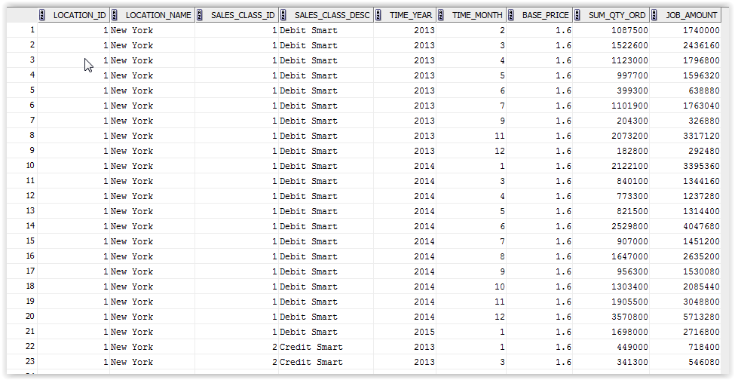

BQ2

--BQ2: Location invoice revenue summary (revenue/costs)

Drop View BQ2;

Create View BQ2

as Select W_JOB_F.JOB_ID

, W_LOCATION_D.LOCATION_ID

, W_LOCATION_D.LOCATION_NAME

, UNIT_PRICE

, QUANTITY_ORDERED

, W_TIME_D.TIME_YEAR

, W_TIME_D.TIME_MONTH

,sum (W_INVOICELINE_F.INVOICE_AMOUNT) as Sum_Invoice_Amount

,sum(W_INVOICELINE_F.INVOICE_QUANTITY) as Sum_Invoice_Qty

From W_JOB_F, W_TIME_D, W_INVOICELINE_F,W_LOCATION_D,W_JOB_SHIPMENT_F

Where w_location_d.location_id = w_job_f.location_id

and W_JOB_SHIPMENT_F.INVOICE_ID = W_INVOICELINE_F.INVOICE_ID

and W_TIME_D.TIME_ID = W_JOB_F.CONTRACT_DATE

and W_JOB_SHIPMENT_F.LOCATION_ID=W_LOCATION_D.LOCATION_ID

Group by W_JOB_F.JOB_ID

, W_LOCATION_D.LOCATION_ID

, W_LOCATION_D.LOCATION_NAME

, UNIT_PRICE

, QUANTITY_ORDERED

, W_TIME_D.TIME_YEAR

, W_TIME_D.TIME_MONTH

Order by Job_ID ;

Select * from BQ2;

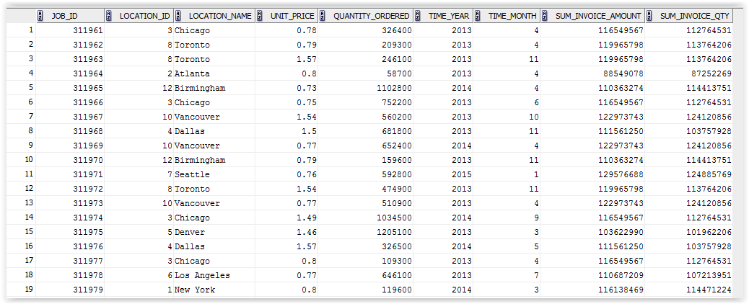

BQ3—

--BQ3: Location subjob cost summary (revenue/costs)

Drop View BQ3;

Create View BQ3 as

Select W_JOB_F.JOB_ID

, W_LOCATION_D.LOCATION_ID

, W_LOCATION_D.LOCATION_NAME

, W_TIME_D.TIME_YEAR

, W_TIME_D.TIME_MONTH

, sum (W_SUB_JOB_F.COST_LABOR) as SumLaborCost

, sum (W_SUB_JOB_F.COST_MATERIAL) as SumMaterialCost

, sum(W_SUB_JOB_F.MACHINE_HOURS*W_MACHINE_TYPE_D.RATE_PER_HOUR) as SumMachineCost

, sum (W_SUB_JOB_F.COST_OVERHEAD) as SumOverhead

, sum (W_SUB_JOB_F.COST_LABOR

+ W_SUB_JOB_F.COST_MATERIAL

+ (W_SUB_JOB_F.MACHINE_HOURS*W_MACHINE_TYPE_D.RATE_PER_HOUR)

+ W_SUB_JOB_F.COST_OVERHEAD)

as SumTotalCost

, sum(W_SUB_JOB_F.QUANTITY_PRODUCED)as SumQtyProduced

--, (SumTotalCost/SumQtyProduced)

From W_JOB_F, W_TIME_D,W_SUB_JOB_F, W_MACHINE_TYPE_D, W_LOCATION_D

Where W_LOCATION_D.LOCATION_ID=W_JOB_F.LOCATION_ID

And W_SUB_JOB_F.JOB_ID=W_JOB_F.JOB_ID

And W_TIME_D.TIME_ID=W_JOB_F.CONTRACT_DATE

And W_MACHINE_TYPE_D.MACHINE_TYPE_ID = W_SUB_JOB_F.MACHINE_TYPE_ID

Group by W_JOB_F.JOB_ID

, W_LOCATION_D.LOCATION_ID

, W_LOCATION_D.LOCATION_NAME

, W_TIME_D.TIME_YEAR

, W_TIME_D.TIME_MONTH

, W_JOB_F.UNIT_PRICE ;

Select JOB_ID

, LOCATION_ID

, LOCATION_NAME

, TIME_YEAR

, TIME_MONTH

, SumLaborCost

, SumMaterialCost

, SumMachineCost

, SumOverhead

, SumTotalCost

, SumQtyProduced

,sum (SumTotalCost / SumQtyProduced) as UnitCost

-- , sum (SumLaborCost + SumMaterialCost + SumMachineHours + SumOverhead) as SumTotalCost

From BQ3

group by JOB_ID

, LOCATION_ID

, LOCATION_NAME

, TIME_YEAR

, TIME_MONTH

, SumLaborCost

, SumMaterialCost

, SumMachineCost

, SumOverhead

, SumTotalCost

,SumQtyProduced;

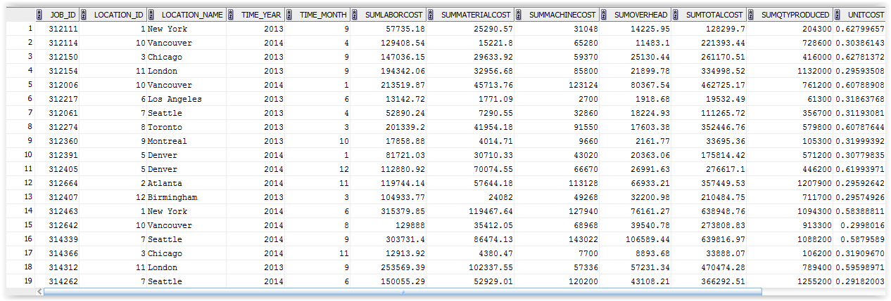

BQ4

--BQ4: Returns by location and sales class (quality control)

Drop view BQ4;

Create View BQ4 as

Select W_LOCATION_D.LOCATION_ID

,W_LOCATION_D.LOCATION_NAME

,W_SALES_CLASS_D.SALES_CLASS_ID

,W_SALES_CLASS_D.SALES_CLASS_DESC

,W_TIME_D.TIME_YEAR

,W_TIME_D.TIME_MONTH

,sum (W_JOB_SHIPMENT_F.ACTUAL_QUANTITY-W_INVOICELINE_F.INVOICE_QUANTITY) as SumQtyRtn

,sum(W_JOB_SHIPMENT_F.SHIPPED_AMOUNT-W_INVOICELINE_F.INVOICE_AMOUNT) as SumDollarRtn

From W_INVOICELINE_F, W_JOB_SHIPMENT_F,W_LOCATION_D,W_TIME_D,W_SALES_CLASS_D

Where w_job_shipment_f.invoice_id = w_invoiceline_f.invoice_id

And W_INVOICELINE_F.INVOICE_SENT_DATE=w_time_d.time_id

And W_SALES_CLASS_D.SALES_CLASS_ID=W_JOB_SHIPMENT_F.SALES_CLASS_ID

and W_JOB_SHIPMENT_F.LOCATION_ID=W_LOCATION_D.LOCATION_ID

and (W_JOB_SHIPMENT_F.ACTUAL_QUANTITY-W_INVOICELINE_F.INVOICE_QUANTITY) > 0

Group by W_LOCATION_D.LOCATION_ID

,W_LOCATION_D.LOCATION_NAME

,W_SALES_CLASS_D.SALES_CLASS_ID

,W_SALES_CLASS_D.SALES_CLASS_DESC

,W_TIME_D.TIME_YEAR

,W_TIME_D.TIME_MONTH

Order by location_ID

;

Select * from BQ4;

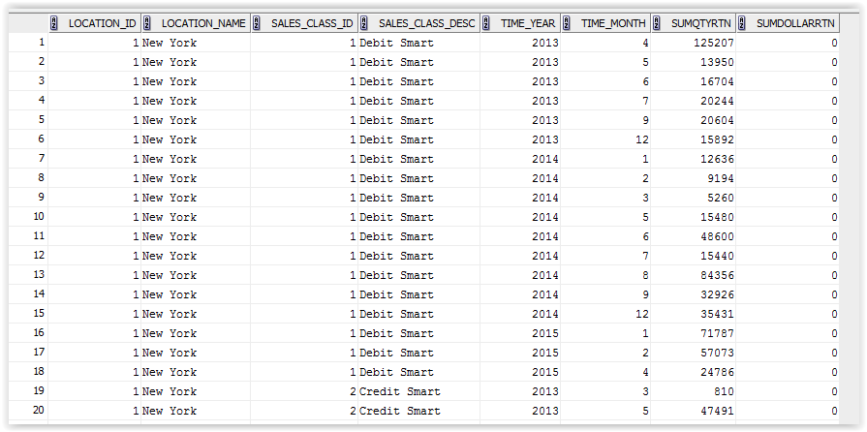

BQ5

--BQ5: Last shipment delays involving date promised (quality control)

Drop view BQ5;

Create view BQ5 as

Select W_JOB_F.job_ID

, W_LOCATION_D.LOCATION_ID

, W_LOCATION_D.LOCATION_NAME

, W_SALES_CLASS_D.SALES_CLASS_ID

, W_SALES_CLASS_D.SALES_CLASS_DESC

, W_JOB_F.DATE_PROMISED

, X1.Last_Shipment_Date

, W_JOB_F.QUANTITY_ORDERED

, getBusDaysDiff (DATE_PROMISED,Last_Shipment_Date) as BusDaysOff

from

-- Use in FROM clause of BQ5

-- X1 is an alias name that can be referenced in the outer query

( SELECT W_SUB_JOB_F.JOB_ID,

MAX(actual_ship_Date) AS Last_Shipment_Date,

SUM ( actual_Quantity ) AS SumDelayShipQty

FROM W_JOB_SHIPMENT_F, W_SUB_JOB_F, W_Job_F

WHERE W_SUB_JOB_F.SUB_JOB_ID = W_JOB_SHIPMENT_F.SUB_JOB_ID

AND W_Job_F.Job_Id = W_SUB_JOB_F.JOB_ID

AND Actual_Ship_Date > Date_Promised

GROUP BY W_SUB_JOB_F.JOB_ID

) X1,W_SALES_CLASS_D, W_JOB_F, W_LOCATION_D,W_TIME_D

Where W_LOCATION_D.LOCATION_ID=W_JOB_F.LOCATION_ID

And W_SALES_CLASS_D.SALES_CLASS_ID=W_JOB_F.SALES_CLASS_ID

And W_TIME_D.TIME_ID=W_JOB_F.DATE_PROMISED

Group by W_JOB_F.job_ID

, W_LOCATION_D.LOCATION_ID

, W_LOCATION_D.LOCATION_NAME

, W_SALES_CLASS_D.SALES_CLASS_ID

, W_SALES_CLASS_D.SALES_CLASS_DESC

, W_JOB_F.DATE_PROMISED

, X1.Last_Shipment_Date

, W_JOB_F.QUANTITY_ORDERED

Order by Job_Id

;

Select * from BQ5; 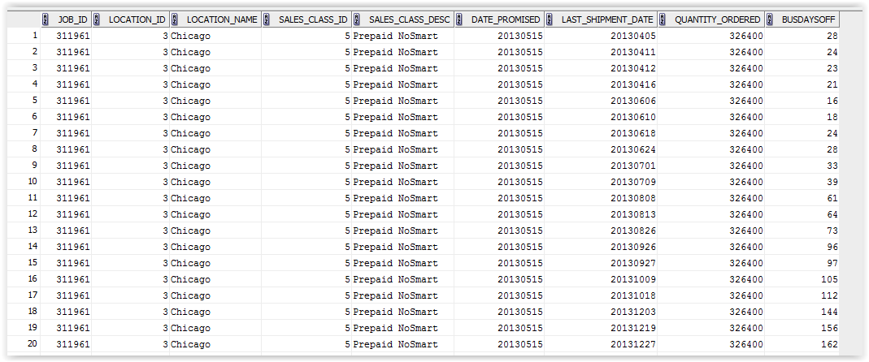

a

BQ6

--BQ6: First shipment delays involving shipped by date (quality control)

Drop View BQ6;

Create View BQ6 as

Select W_JOB_F.job_ID

, W_LOCATION_D.LOCATION_ID

, W_LOCATION_D.LOCATION_NAME

, W_SALES_CLASS_D.SALES_CLASS_ID

, W_SALES_CLASS_D.SALES_CLASS_DESC

, W_JOB_F.DATE_SHIP_BY

, W_JOB_F.CONTRACT_DATE

, X1.FirstShipDate

, getBusDaysDiff (W_JOB_F.CONTRACT_DATE,x1.FirstShipDate) as BusDaysOff

From

-- Use in FROM clause of BQ6

-- X1 is an alias name that can be referenced in the outer query

( SELECT W_SUB_JOB_F.JOB_ID, MIN(Actual_Ship_Date) as FirstShipDate

FROM W_JOB_SHIPMENT_F, W_SUB_JOB_F

WHERE W_SUB_JOB_F.SUB_JOB_ID = W_JOB_SHIPMENT_F.SUB_JOB_ID

GROUP BY W_SUB_JOB_F.JOB_ID

) X1,W_JOB_F, W_LOCATION_D, W_SALES_CLASS_D,W_TIME_D

where W_JOB_F.LOCATION_ID=W_LOCATION_D.LOCATION_ID

And W_SALES_CLASS_D.SALES_CLASS_ID=W_JOB_F.SALES_CLASS_ID

And W_TIME_D.TIME_ID=W_JOB_F.DATE_SHIP_BY

Group by W_JOB_F.job_ID

, W_LOCATION_D.LOCATION_ID

, W_LOCATION_D.LOCATION_NAME

, W_SALES_CLASS_D.SALES_CLASS_ID

, W_SALES_CLASS_D.SALES_CLASS_DESC

, W_JOB_F.DATE_SHIP_BY

, W_JOB_F.CONTRACT_DATE

, X1.FirstShipDate

--, getBusDaysDiff (CONTRACT_DATE,x1.FirstShipDate)

Order by Job_Id

;

Select * From BQ6;

